
BCS 3101: MACHINE LEARNING
Year: 3 Semster 1
ASSIGNMENT 2
Predicting Monthly Maize and Beans Prices in Selected Ugandan Markets Using Historical Price and Market Data
Github repo:
https://github.com/Allan12377/BCS3101-Assignment2-Maize-Beans-Prices
Group Members
No. | Names | Reg no.
1. | AYEN GEOFFREY ALEXANDER | 2024/A/KCS/5102/G/F
2. | KUKUNDAKWE SAVIOUS | 2024/A/KCS/4333/F
3. | AINEBYONA ALLAN | 2024/A/KCS/1670/F
4. | KYOSHABIRE DIANAH | 2024/A/KCS/5188/G/F
5. | NIYONSHUTI MERCY | 2025/A/KCS/6117/F
6. | ARINDA ELIZABETH | 2024/A/KCS/3099/G/F
7. | GUMISIRIZA AMBROSE | 2024/A/KCS/3143/F

1. Title
Predicting Monthly Maize and Beans Prices in Selected Ugandan Markets Using Historical Price and Market Data
2. Background
Food prices affect the daily lives of many people in Uganda. Maize and beans are staple foods. When their prices rise quickly, households, traders and aid organisations feel the effect. A model that can estimate future prices from past market data can support better planning.
This project treats the task as a regression problem. The goal is to predict the monthly price of maize and the monthly price of beans. The predictors include the month, the year, the market location, related food prices, inflation indicators and a few coverage scores.
The work follows the standard data-mining pipeline of cleaning, integration, transformation and reduction. That pipeline sits inside the broader Knowledge Discovery in Databases process of turning raw data into useful insight [1], [2]. The report shows each decision with numbers and charts taken from the project notebooks.
3. Data Description
The dataset is the Uganda RealTime Food Prices (RTFP) series publishd by the World Bank Development Economics Data Group. The prices are collected from the World Food Programme and the Food and Agriculture Organization. Some missing market observations are filled by machine-learning estimates. The completed series begin with the prefix c_ [3].
We selected seven markets that give good geographic coverage and full monthy records from 2007 to 2026: Market Average, Gulu, Lira, Jinja, Hoima, Busia and Mbarara. After filtering, the working table contains 1 652 rows and more than 100 columns. The two target variables are c_maize and c_beans (completed monthly prices in Uganda shillings per kilogram).
The original observed columns (maize, beans, oil, salt and others) contain many missing values. The completed columns have zero mising values. This pattern is expected for an RTFP produucts that combines direct measurement with estimation.
Table 1 summarises the key facts about the working dataset.
Item | Value
Source | World Bank RTFP (WFP / FAO)
Markets kept | 7 (Market Average, Gulu, Lira, Jinja, Hoima, Busia, Mbarara)
Rows after filter | 1 652
Time span | January 2007 – August 2026
Main targets | c_maize, c_beans (UGX per kg)
Table 1. Summary of the working dataset.
4. Data Preprocessing Techniques Applied
4.1 Data Cleaning
Missing values were counted for every column. The completed targets c_maize and c_beans had zero missing values, so they were kept as the regression targets. The original observed price columns had missing rates above 50 percent. Those columns where retained only for comparison and were not used as model features. Columns that were almost empty, such as salt, were marked for removal during feature selection.
Exact duplicate rows were checked with the duplicated method. No exact duplicates were found. Each market-month combination appears only once.
Outliers in the two targets were detected with the interquartile-range rule of Tukey [4]. A number of high prices were flagged. These points appear across many years and match known periods of market stress. They were therefore retained as genuine observations rather than removed or capped.
4.2 Data Integration
Data integration was not applicable. The project uses a single unified source file. The companion guide states that an explicit statement of this kind is preferred to a silent omission [5].
4.3 Data Transformation
The market name is a nominal categorical variable. It has no natural order. One-hot encoding with the first category dropped was therefore applied. This avoids creating a false numeric order and also avoids the dummy-variable trap [6].
Feature scaling was performed with the Z-score method (StandardScaler). Prices are measured in thousands of Uganda shillings while month is only 1 to 12. Without scaling, distance-based or gradient-based algorithms would be dominated by the price columns. StandardScaler was chosen because it is more robust to the high prices that were retained during cleaning. The scaler was fitted only on the training partition after the train-test split, following the guide’s rule against data leakage [5].
4.4 Data Reduction and Splitting
Correlation among the numeric features was examined. Maize and beans prices move together and both rise with the food-price index and with year. The number of features remained modest (under twenty). Principal Component Anallysis was explored; enouhg components to explain 95 percent of the variance were identified. PCA was nevertheless not used for modelling. The original features are already interpretable, and the guide credits a reasoned decision to omit PCA when feature count is small [5].
An 80/20 train-test split with random_state equal to 42 was applied. Because the problem is regression, class-imbalance methods were not required.
5. Exploratory Data Analysis
Exploratory data analysis is the largest single criterian on the rubric (20 percent). At least one technique from each of the six categories required by the guide is presented below, together with a short interpretation.
5.1 Descriptive Statistics
Both target series are right-skewed. The mean lies above the median because of a long tail of high prices. This pattern is common in market-price data and supports the later suggestion that robust error metrics or a log transform may be useful.
5.2 Univariate Analysis
Figure 1 shows the histograms of the two targets. Both distributions peak on the left and extend to the right. Figure 2 shows the corresponding box plots. The points beyond the whiskers are the same high prices retained during cleaning.
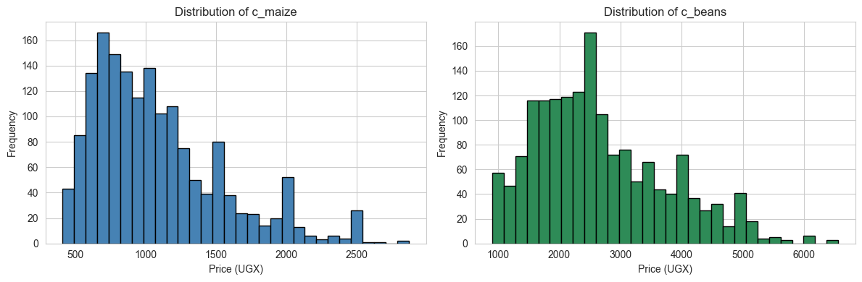
Figure 1. Histograms of completed maize and beans prices.
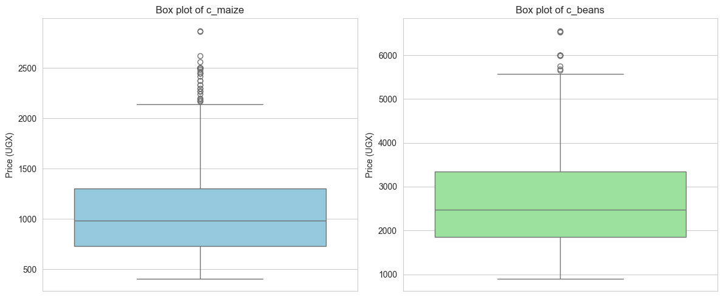
Figure 2. Box plots of completed maize and beans prices.
5.3 Bivariate and Multivariate Analysis
Figure 3 presents the correlation heatmap. Maize and beans prices are strongly positively correlated. Both also rise with the food-price index and with calendar year. Figure 4 shows the average price of each crop by year; a clear upward trend is visible from 2007 onward. Figure 5 is a scatter plot of maize against beans and confirms the positive linear relationship.
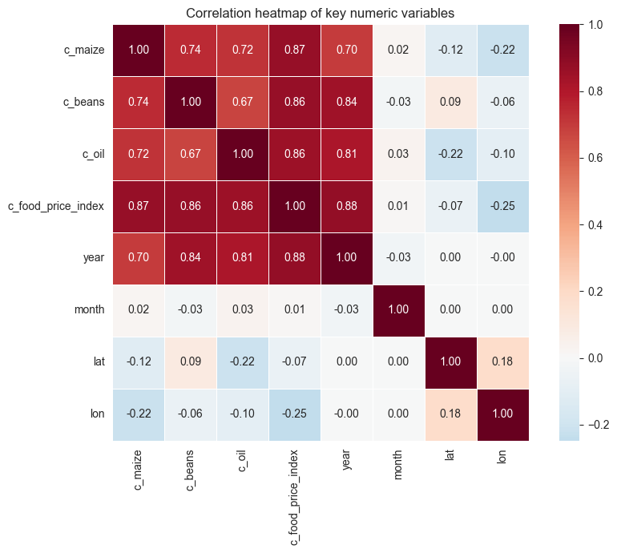
Figure 3. Correlation heatmap of key numeric variables.
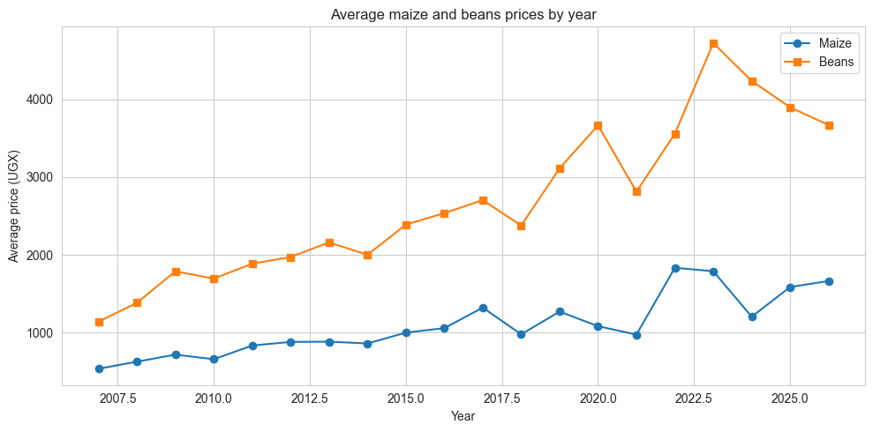
Figure 4. Average maize and beans prices by year. 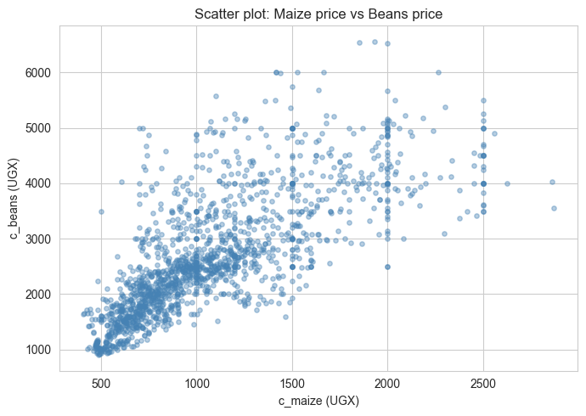
Figure 5. Scatter plot of maize price against beans price.
5.4 Missing-Data Visualisation
Figure 6 shows the percentage of missing values in the original observed price columns. Rates above 50 percent are common. The completed series used as targets have no missing values. This contrast guided the decision to rely on the completed prices for modelling.
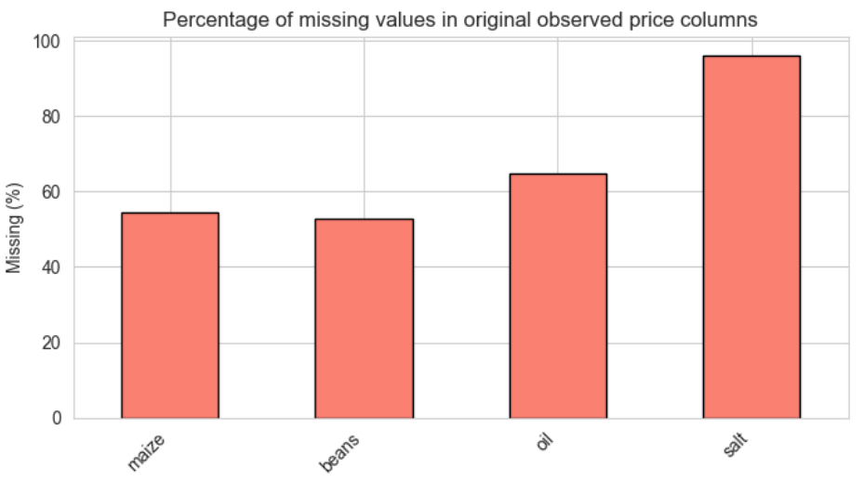
Figure 6. Percentage of missing values in original observed price columns.
5.5 Outlier Visuals and Target Analysis
The high-price points flagged by the interquartile-range rule appear in several different years. They are not concentrated in a single short crisis. This supports the decision to keep them. Both targets remain continuous and right-skewed after cleaning. For modelling, mean absolute error or median absolute error will be more robust than metrics that assume symmetric errors. A log transform of the targets remains available if a later algorithm benefits from more normal residuals.
6. Conclusion and Next Steps
The data have been cleaned, encoded, scaled and split according to the stages required by the companion guide. The completed maize and beans price series are ready for regression modelling. The main patterns observed are a long-term upward trend, a strong positive link between the two crops, and genuine high-price episodes that should be retained.
The next step is to train and compare a small set of regression models (for example linear regression, random forest and gradient boosting) on the prepared training set and to evaluate them on the held-out test set using robust error metrics. Feature importance and residual analysis can then refine the choice of predictors.
7. References
[1] J. Han, M. Kamber, and J. Pei, Data Mining: Concepts and Techniques, 3rd ed. Morgan Kaufmann, 2011.
[2] U. Fayyad, G. Piatetsky-Shapiro, and P. Smyth, “From data mining to knowledge discovery in databases,” AI Magazine, vol. 17, no. 3, pp. 37–54, 1996.
[3] World Bank, “Uganda – Monthly food price estimates by product and market (RTFP),” Microdata Library, 2026. [Online]. Available: https://microdata.worldbank.org/catalog/8241
[4] J. W. Tukey, Exploratory Data Analysis. Addison-Wesley, 1977.
[5] Kabale University, BCS 3101 Assignment 2 Companion Guide: The Data Pre-processing & Exploratory Data Analysis Pipeline, 2026.
[6] F. Pedregosa et al., “Scikit-learn: Machine learning in Python,” Journal of Machine Learning Research, vol. 12, pp. 2825–2830, 2011.
[7] W. McKinney, “Data structures for statistical computing in Python,” in Proc. 9th Python in Science Conf., 2010, pp. 56–61.
[8] D. B. Rubin, “Inference and missing data,” Biometrika, vol. 63, no. 3, pp. 581–592, 1976.

